CONFIDENTIALITY LETTER

Dear Sir,

In consideration of our disclosing to your certain confidential data and other information (hereinafter referred to as “the Confidential Information”) relating to Xerve, we require you to give the following undertakings:

1. All Confidential Information disclosed to you shall be kept secret and confidential and shall be disclosed only to such persons as are required to be directly concerned with the Confidential Information.
2. You shall not without prior consent use the Confidential Information for any other purpose other than to evaluate the practical and commercial viability of the project as we shall direct.
3. Except as set out above or agreed by us in writing you shall not use, copy in whole or in part, modify or adapt the Confidential Information in any way and at our written request shall cease all use of the Confidential Information and return or destroy all copies of the Confidential Information in your possession.
4. You shall remain bound by the undertakings given in this letter without limit in time.
5. This agreement shall be governed by Kenyan law and the Kenyan courts will have jurisdiction over any dispute or claim arising in connection with it.

If you agree to the above terms, please sign the statement at the foot of the enclosed copy of this letter and return it to us.

Yours faithfully

I agree to the foregoing

Name: Emmanuel Rudolf Jocondo Organisation: Xerve

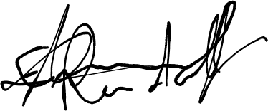Date: 02/08/2020

# X

Name: Samuel Munyiri Wanjiru

Organisation: Sarijen Media

Date:02/08/2020

# Samuel